**The Janda Baik History**

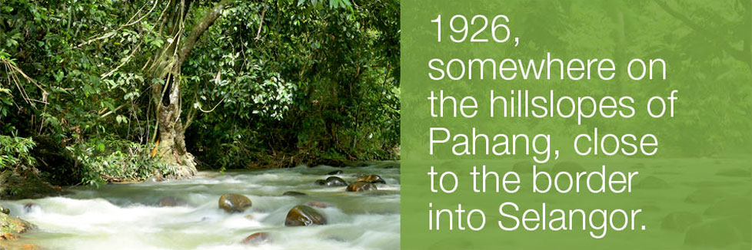

It was a tough time. A great flood had hit much of Peninsular Malaya, and the villages along meandering Sungai Benus in Pahang were badly affected. Many of the small ‘kampung’ (villages) perched on the riverbanks were washed away. Villagers up and down the river were struggling to make ends meet; it was getting impossible to continue living there.

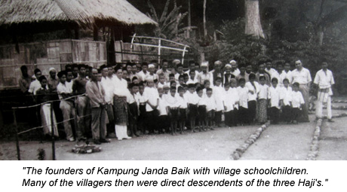

Amongst those suffering were three ‘Haji’s’ – Haji Deris, Haji Yasih and Haji Kadir. They knew it was pointless to try and rebuild their village, and decided it would be best to seek out a new home. Walking for some miles, they came upon a picturesque point, with gentle slopes and flowing streams. The setting, they felt, was perfect for their new village, and they proceeded to set up home.

Enlisting the help of some of the local “Orang Asli Temian” (aborigines from the Temian tribe), the three enterprising gentlemen planted padi to sustain themselves and their growing families. The village, having no name, was often informally referred to as ‘Kampung Tiga Haji’ (the village of the three ‘Haji’s’).

Life continued peacefully; the families married and intermarried, and its population grew. Life was good. Around 1932, an incident happened that gave the village its first proper name. It so happened that amongst the Orang Asli helping the three ‘Haji’s’ plant and harvest padi was a couple; he was called Batin (traditional healer) Emok, she was named Endut. According to village folklore, the couple, both unhappy with their marriage, decided to separate. Each left, taking a different path out of the village.

After walking for barely a month, both started thinking about all the effort they had put into the planting of the padi, which would be ready for harvesting soon. And so each decided, of their own volition, to head back to the village to claim their share of the padi harvest.

Enroute back to the village, they met at the junction of Pulau Santap, an area at the confluence of the Sungai Benus and Sungai Cheringging rivers. ‘Pulau’ means island, and ‘Santap’ is the royal term for eating. In ancient times, a small island rose above the confluence of these two rivers, creating a peaceful spot where Pahang sultans would stop for a leisurely meal during their travels around the state.

Against this romantic and peaceful backdrop, the couple set aside their differences and rekindled their love. Following the happy reunion, they decided to make a life together again in the village, where they lived happily ever after. The villages, captivated by their story, decided to name the village ‘Kampung Janda Balik’ (The Village of the Returning Divorcee).

But the story doesn’t end there, and neither did the name stick for long. A few years later, an English Colonial District Officer by the name of Mr Peacock visited the village. Hearing the story of the returning divorcees, Mr Peacock suggested that the village be called ‘Kampung Janda Baik’ (the good divorcees, or possibly the divorcees who made good). And the name has stuck ever since!



(As narrated by Tuan Haji Muhamed Atal bin Haji Abdul Manap (picture), grandson to one of the original village leaders)